**Finite Difference Method - Explicit Scheme**

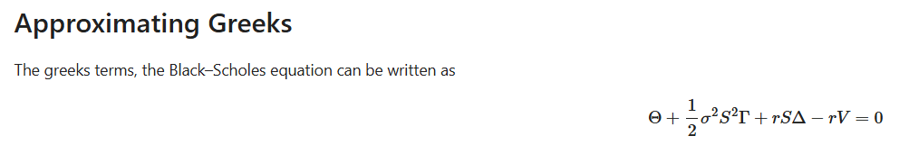

Theta is approximated as below. Note that time step on the grid is changing from k to k+1 but asset price step is unchanged at i.

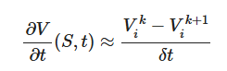

Consider the following two Taylor series expansions. If you sum take their difference, you’ll get delta and if you sum them then you’ll get gamma.





Delta is approximated as below. Note that asset price step is changing from i+1 to i-1 but time step is unchanged at k.

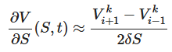

Gamma is approximated as below.

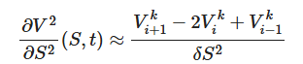

Now, plug these greeks in the black scholes PDE. You’ll see that only theta has Vik+1 term, which means the value of option at the same asset price but next time step. You solve for this using Vik,Vi+1k and Vi-1k. So, you compute option values at maturity (this is known) and using them you back calculate the option price today by filling values in the grid.

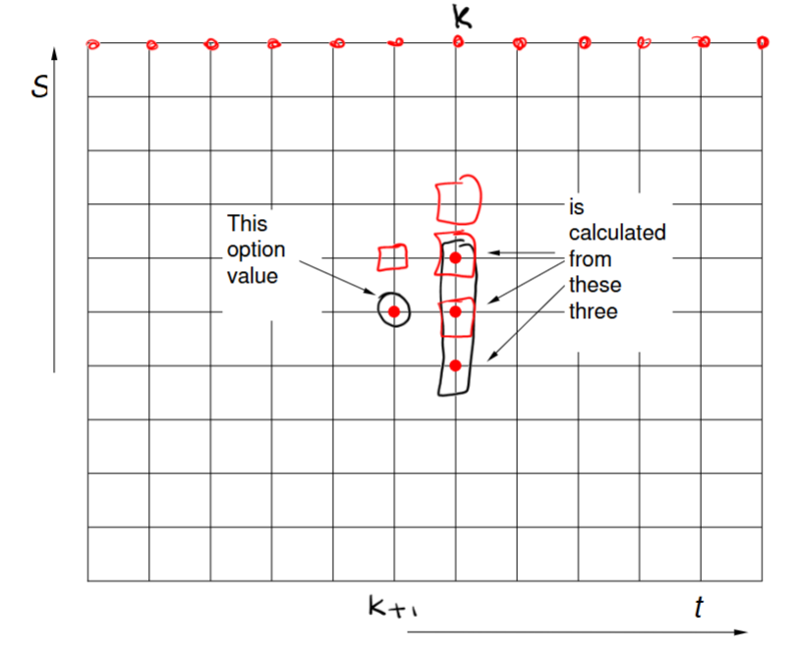

Boundary Conditions:

For call options if underlying price is 0, then value of option is 0.

And if the underlying price tends to infinity, then delta would be approx. 1 and gamma 0. Therefore:



We now know all values at terminal and boundary nodes. This is sufficient to fill the entire grid backwards.

